# DevOps and Testing

**# Source**: **Chatgpt (GPT-5-Standard) at [8/13/2025]**

**DevOps and Testing** are closely connected — DevOps isn’t just about automating deployments, it’s also about **integrating testing into every stage of the software delivery pipeline** so quality is built in from the start.

## 1. What is DevOps in this context?

**# Source**: **Chatgpt (GPT-5-Standard) at [8/13/2025]**

* **DevOps** = A culture and set of practices that bring **development** and **operations** together to deliver software **faster, more reliably, and with continuous feedback**.
* It uses **automation**, **collaboration**, and **continuous integration/continuous delivery (CI/CD)** to achieve this.
* In DevOps, testing isn’t a separate phase — it’s an **ongoing activity** embedded in the pipeline.

## 2. Role of Testing in DevOps

**# Source**: **Chatgpt (GPT-5-Standard) at [8/13/2025]**

In DevOps, testing is:

* **Continuous** – Happens throughout the lifecycle, not just before release.
* **Automated** – So tests run quickly and consistently after every change.
* **Integrated** – Built into the CI/CD pipeline so no build gets deployed without passing required tests.

## 3. Types of Testing in DevOps Pipelines

**# Source**: **Chatgpt (GPT-5-Standard) at [8/13/2025]**

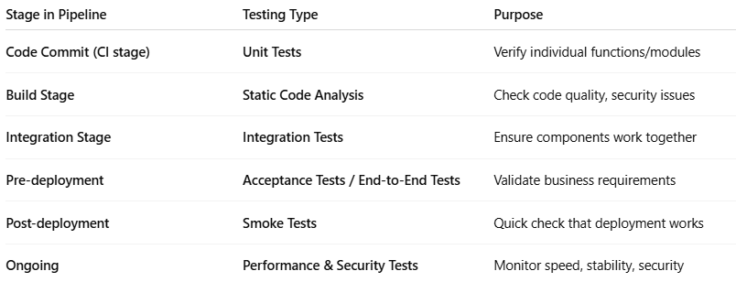

| **Stage in Pipeline** | **Testing Type** | **Purpose** |
| --- | --- | --- |
| **Code Commit (CI stage)** | **Unit Tests** | Verify individual functions/modules |
| **Build Stage** | **Static Code Analysis** | Check code quality, security issues |
| **Integration Stage** | **Integration Tests** | Ensure components work together |
| **Pre-deployment** | **Acceptance Tests / End-to-End Tests** | Validate business requirements |
| **Post-deployment** | **Smoke Tests** | Quick check that deployment works |
| **Ongoing** | **Performance & Security Tests** | Monitor speed, stability, security |

## 4. Benefits of Testing in DevOps

**# Source**: **Chatgpt (GPT-5-Standard) at [8/13/2025]**

* **Early bug detection** → cheaper to fix issues when found early.
* **Faster feedback loop** → developers know within minutes if they broke something.
* **Higher confidence in releases** → deployments are less risky.
* **Better collaboration** → QA, Dev, and Ops share responsibility for quality.

## 5. Example – Testing in a DevOps CI/CD Pipeline

**# Source**: **Chatgpt (GPT-5-Standard) at [8/13/2025]**

1. **Developer pushes code** → triggers pipeline.
2. **Pipeline runs:**
   * Unit tests
   * Static code analysis
   * Integration tests
   * Acceptance tests
3. **If all pass** → automatic deployment to staging or production.
4. **After deployment** → smoke tests + monitoring.

💡 **Key Point:** In DevOps, *testing shifts left* — it moves earlier in the process and becomes **everyone’s responsibility**, not just QA’s.